

JobREADY kit

How to use this kit
CV Development
- CV Builder
- CV Hacks
The Application Process
- Application Checklist
- Adjusting your CV
- Covering Letters
Interview Preparation
- Soft Skills
- STAR Stories
- Checklists

Prepare yourself for job applications and interviews

Update this kit before each new job to ensure you’re fully equipped and ready to go

How to Use the Kit

Woah – that’s long – I’ll never complete
all THAT!
Use as much or as little of the kit as you like. Obviously – the more you complete, the better prepared you’ll be. Some people complete a few questions each week.
What is the kit?
A tool to prepare yourself for job applications and interviews

When should I use it?
You can complete it at any time, and it’s a good idea to fill it out before you start applying so you have plenty of time to think.
Then you can go back to it ahead of any new job application or interview and update your answers – so they are fresh in your mind.

CV Builder

CV = Curriculum Vitae
Use the CV builder…
on the following pages to make sure you have all the information you will need.
Then get going on your CV
Meaning course of life, it provides a record of your qualifications, skills and experiences.
Some employers will ask you to provide this as a document; some will ask for the information to be put into their application form.
Either way you will need the information ready when you apply.

Full Name | Email Address | Phone Number
Use the name you would like to be known by. You can give your legal name (if it is different) when you get the job and need to complete the official paperwork | Keep it professional!  Do  - Keep it simple  - Include your name  - Use Gmail / Outlook / iCloud or your own domain  - Use clear, recognisable words  Don’t  - Include reasons for discrimination Age (year of birth)/ethnicity/religion  - Avoid using outdated domains like AOL / Hotmail / BTInternet  - Avoid drink / drug / gaming references – basically don’t try  to be funny  - Don’t use your school or  college email – you  might lose access | Do  - Use a number you will answer. If you have to use a shared number, try to be the person who answers it.  - Make sure anyone who might answer the phone knows the name you have put on your CV  - Break the number into chunks so it’s easy to read  Like this: 07770 123 456  Don’t  - Give a work number your current boss might answer
Contact Information

GOOD  Jane_Doe@gmail.com  contact@janedoe.co.uk*  Jane.Doe.UK@icloud.com  Obviously – use your name not Jane Doe! ☺  * You will have to pay for your own domain and email handling | AVOID  SexyGamer2007@AOL.com  ZombieSlayerz@SkibbidiRizz.com  PleaseHireMe@btinternet.com  BowlingGenius@hotmail.com  AmazingSinger@icloud.com  JaneTherapist@doe.co.uk

Example Email Addresses

Education
Keep a record of all dates
You may one day be asked for a full employment history. You may need to pick a date from an online calendar – so you’ll
need day, month and year.
Next – you’ll need to list your educational qualifications
  - Date(s)
  - Name of school / college
  - Qualification subject or title
Use the following pages to record these. Add new qualifications as you achieve them through your life.

GCSEs or equivalent
School / College
Include location
Dates
Subject | Result / Grade
English Language | Grade 6

A’ Levels or equivalent
School / College
Include location
Dates
Subject | Result / Grade
English Language | Grade 6

Higher Education
Degrees & Diplomas
School / College
Include location
Dates
Subject | Result / Grade
School / College
Include location
Dates
Subject | Result / Grade
School / College
Include location
Dates
Subject | Result / Grade
School / College
Include location
Dates
Subject | Result / Grade

Professional & Vocational Qualifications
Certificates & Business

Here are some examples of qualifications you should keep a record of.
Don’t forget to keep any certificates, you may be asked to show them when you start a job.
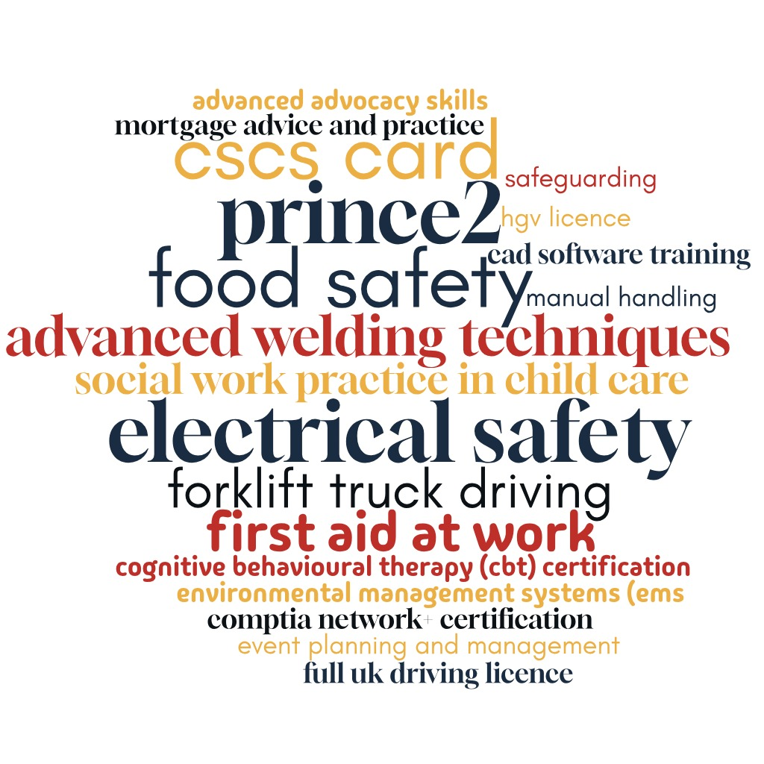

Professional & Vocational Qualifications
Certificates & Business
School / College
Include location
Dates
Subject & Level | Result / Grade
School / College
Include location
Dates
Subject & Level | Result / Grade
School / College
Include location
Dates
Subject & Level | Result / Grade
School / College
Include location
Dates
Subject & Level | Result / Grade
Note
These qualifications are usually just pass
or fail.
So, you may not need to list the grade.

Note
When adapting your CV for a job, make sure you focus on what is relevant to the role you want
Work Experience
Work experience is often just as important as qualifications. Be sure to include any voluntary work as well as employment.
Work Experience
Organisation
Include location
Dates
Role / Job Title
Key responsibilities

Work Experience
Organisation
Include location
Dates
Role / Job Title
Key responsibilities
Organisation
Include location
Dates
Role / Job Title
Key responsibilities

Work Experience
Organisation
Include location
Dates
Role / Job Title
Key responsibilities
Organisation
Include location
Dates
Role / Job Title
Key responsibilities

Skills & Qualities – Employability
Note
Choose relevant skills for the job you are applying for and make sure they are in your CV or covering letter.
Be careful – if you list ‘attention to detail’ make sure you don’t have any typos in
your application.
Keep a list of all skills you have developed.
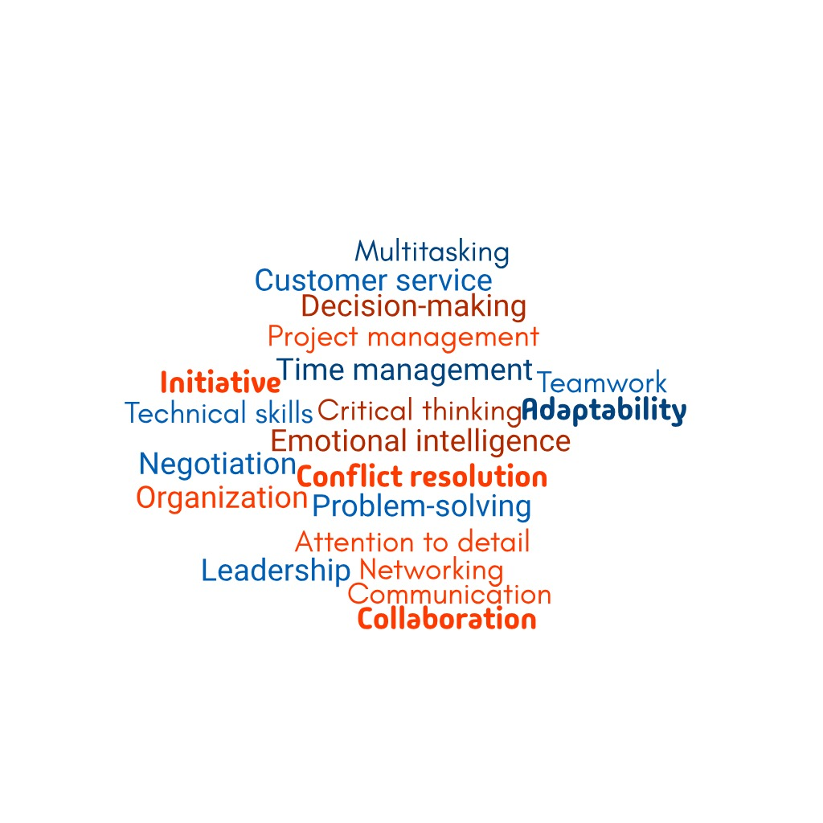
These are example transferable employability skills – what are
yours?

Employability Skills
Skill or Quality | How would you rate yourself?
Adaptability
Choose wisely
You may be asked questions at interview about these skills, so be prepared to justify the rating you have given yourself

Skills & Qualities – Technical
Note
Be specific when talking about systems you are familiar with.
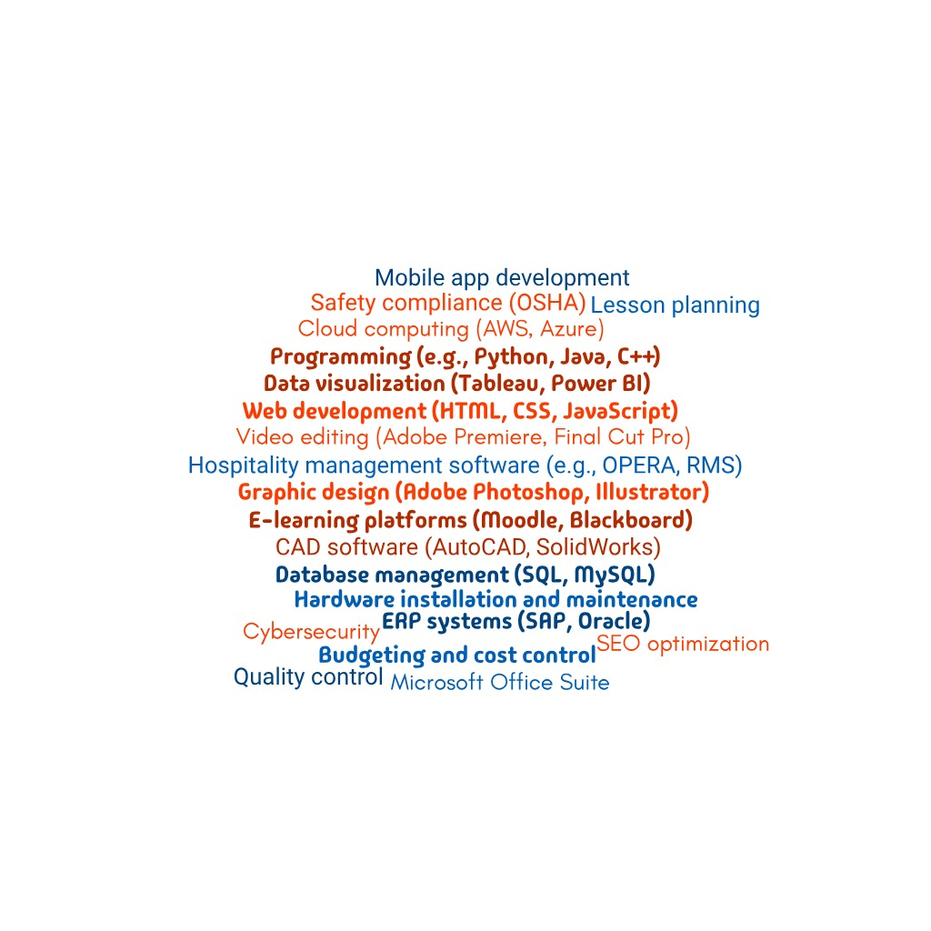
Here are some examples of technical skills. What are your technical skills?

Technical Skills
Skill or Quality | How would you rate yourself?
PhotoShop
Not sure - ask
Can’t think of anything you are good at? Ask your friends, family, teachers or work colleagues

CV Hacks
Quality not quantity
Keep it to a maximum of 2 x A4 pages
Keep it brief and to the point
Hiring managers do not have time to read in depth text. Bullet points and short sentences which are packed with key words will get noticed
Make it clear
Choose a design that makes it easy to read. Use columns and graphics.
Format
Always save your CV as a PDF and embed the fonts, if you can.
A4 is the normal paper size for a CV in the UK. However, this may change, so keep an eye on current trends.
Gaps in employment
If you have been in prison what to put will depend on your experience, so seek advice.
Things you don’t need to include | Things that are easy to forget
Your age, gender and sometimes your name  To help against unconscious bias, employers may now ask you for a version of your CV that removes these  Anything older than 10 years  Unless specifically asked for a Full Employment History for Safeguarding reasons | - Have you put your driving licence on?  - Links to your personal website or appropriate Social Media accounts  - Voluntary work – this is just as important as paid work on your CV  - References – you can write ‘References Available on Request’ this saves you asking them before every job application  - Languages – do you speak more than one?  - Gaps in employment – If you have been ill or had caring responsibilities, for example, these should be mentioned and can often highlight some of your skills.

Design
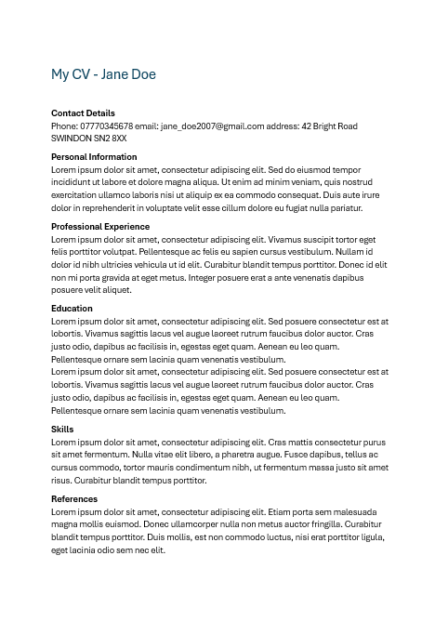
Make sure it is clear and easy for the hiring manager to see the information

- Not like this…

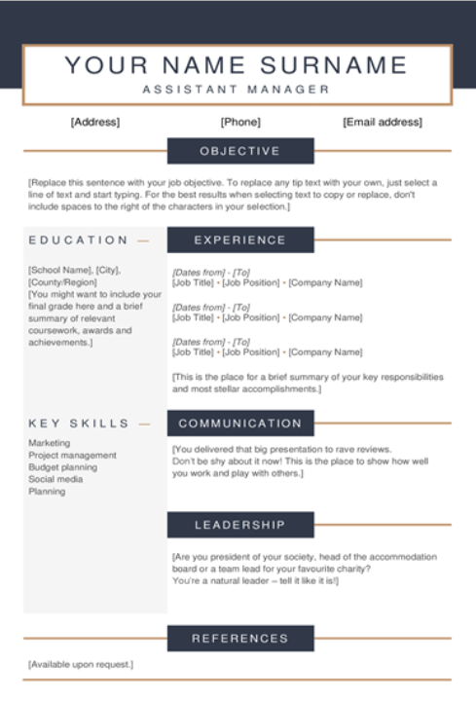

- Try something like this…

This is a default template from Microsoft Word
You can find a range of
other free templates
and ideas online

The Application Process
Application Forms
To apply for a job, you will need to fill out an application
These days these are almost always online. Follow these fundamentals:
- Start the form well ahead of the submission deadline
- Look at the form before you start & find out:
  - Can you save it and come back to it?
You may get timed out or need to find something and come back later; so if you can’t save as you go along, copy and paste your answers into a document
  - Do you have everything you need to fill it out?
- Check it thoroughly for mistakes and typos. Get someone else to look over it, if you can
- Keep/print a copy
It’s good to refresh your memory when it comes to the interview, especially if you’re applying for lots of jobs
Adjusting your CV
If you are serious about a job, make sure your CV and covering letter show that
Adapt your CV for the job you want
- Highlight different skills
- Add in key words from the job description
- Say more about previous jobs or experiences which are relevant to this job
- Say less about ones which have nothing to do with it
Covering Letter
You should write this fresh every time to make sure you know what the organisation is looking for

Application Checklists
Be very careful…
If you are asked for money as part of the application process.
This could be a scam!
Make sure you keep this in mind before you start
Your application should show that…
- You have researched the organisation
You can comment on their goals in your covering letter
- You have read the job ad and description carefully
Use language from the job description in your CV to describe your skills or qualifications
Email
- Is professional and doesn’t look like a gamer tag!
Get Social
- Make sure your Social Media reflects a person they will be
happy to hire
(or make it private)
Referees
- Get permission to
include them
Make sure you have done these before you hit ‘Submit’
- Check you have included everything they have asked for
e.g.
  - CV
  - Covering Letter
  - References
  - Any documents or proof of qualifications
  - Random requests to make sure you’ve read everything
- Proof-read for spelling and grammar.
Even if you’re good at this, it’s always a good idea to get someone you trust to look at it too. You can also run blocks of text through AI.
Covering Letters
Your covering letter is your chance to shine
If you are applying by email…
your covering letter will be the content of your email not an attachment
What hiring managers are looking for:
- Evidence you are passionate about the job
- That you have the skills and knowledge to do the job
What to include
- The role you are applying for
- That you are suitable for the role and why
- Your experience: use words from the job ad or description
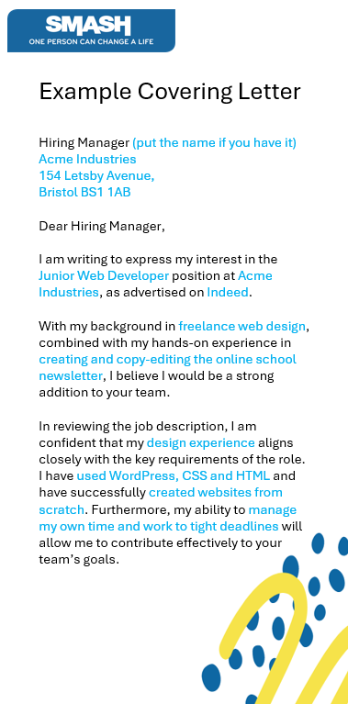
- A conclusion that reenforces your enthusiasm for the role
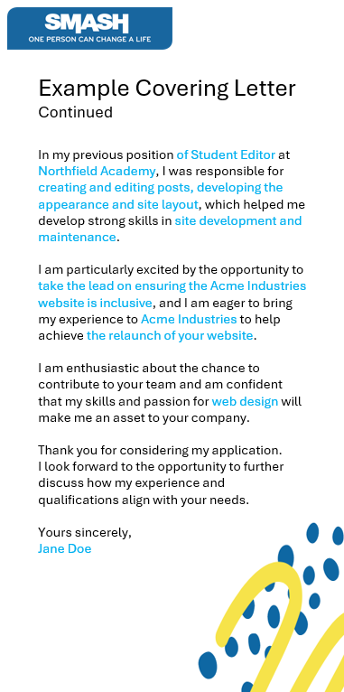
Hiring Manager (put the name if you have it)
[Company Name]
[Company Address]
[City, Postcode]
Dear Hiring Manager,
I am writing to express my interest in the [Job Title] position at [Company Name], as advertised on [where you found the job listing].
With my background in [relevant field or industry], combined with my hands-on experience in [specific skills or tasks mentioned in the job ad], I believe I would be a strong addition to your team.
In reviewing the job description, I am confident that my [relevant experience] aligns closely with the key requirements of the role. I have [mention specific skill or qualification], and have successfully [provide an example of your work or achievement that aligns with the job description]. Furthermore, my ability to [mention another key skill or responsibility from the job ad] will
allow me to contribute effectively to your team’s goals.
In my previous position at [Previous Company Name], I was responsible for [mention specific tasks that relate to the job you’re applying for], which helped me develop strong skills in [key areas that match the job description]. I am particularly excited by the opportunity to [mention a specific responsibility or project mentioned in the job ad], and I am eager to bring my experience to [Company Name] to help achieve [specific goal or value of the company]. I am enthusiastic about the chance to contribute to your team and am confident that my skills and passion for [industry or specific field] will make me an asset to your company.
Thank you for considering my application.
I look forward to the opportunity to further discuss how my experience and qualifications align with your needs.
Yours sincerely,
[Your Full Name]

Interview Preparation

What is an Interview for?
Remember
An interview is your chance to sell your qualities and convince
them you’ll be a great asset to their team

Interviews are often a very bad way of working out whether someone is a good fit for the job.
Unfortunately, they are still a common way for hiring managers to get an insight into the candidates.

How to smash your interview!
Try to get into the head of the hiring manager and give them what they are looking for
- Use your research on the job and the company to find key things to talk about
- Play the part – think about what they are looking for. Sell the things that you are good at and acknowledge areas you are working on.
- Practice, so you are confident

Interview Types
Interviews can take many forms. When you are offered the interview, it should be made clear what to expect. If not, ask.
Traditional One-on-One Interview  A face-to-face meeting with the hiring manager or recruiter where you discuss your qualifications, experience, and fit for the role.  Panel Interview  You are interviewed by a group of interviewers, typically from different departments or levels within the organization, who take turns asking questions.  Phone Interview  A remote interview conducted over the phone, often used as an initial screening to determine if you’re a good fit before an in-person interview.  Video Interview  Conducted via video call (e.g., Zoom, Skype) and often used for remote roles or as a first-round interview, especially for global companies.  Behavioural Interview  Focuses on how you handled past situations to predict future behaviour. Interviewers use questions like "Tell me about a time when..." to assess problem-solving, teamwork, and other skills. | Group Interview  Involves multiple candidates being interviewed at once, where you may work on a group task or answer questions in front of the group, assessing how you interact with others.  Case Interview  Typically used for consulting and analytical roles, where you’re asked to solve a business problem or case study in real time, testing your critical thinking and problem-solving skills.  Competency-Based Interview  Focuses on assessing specific competencies or skills required for the role, such as leadership, communication, and teamwork, through examples of your past work.  Informational Interview  A casual conversation with someone in the industry to learn more about a role, company, or career path. It’s not a formal interview but can help expand your network and knowledge.  Stress Interview  Designed to test how you handle pressure, these interviews may include aggressive questioning, rapid-fire questions, or challenging scenarios to see how you perform under stress. | Technical Interview  Designed to assess your job-specific skills, such as coding, problem-solving, or technical knowledge. These interviews often include practical exercises or tests.  Lunch or Dinner Interview  An interview conducted over a meal, where the goal is to assess your social skills and professionalism in a more relaxed, informal setting.  Assessment Centre Interview  Often used for graduate or management roles, candidates complete a series of exercises or tasks (e.g., role-playing, group activities, written tests) to assess various skills.  Hiring Manager Interview  Focused on evaluating whether you're a good fit for the specific role within the team or department. It’s often more focused on your experience and ability to perform the job.  Second-Round Interview  After a successful initial interview, this round typically goes deeper into your skills, experience, and motivation for the role. You may meet with additional team members or higher-level executives.

Soft Skills
These are often hardest to talk about at interview if you aren’t prepared
So, it is well worth spending time thinking about where you excel and where you may need some support

Problem solving
You may be asked questions such as…
‘Can you tell me about a time when you solved a tricky problem?’
‘Tell me about a time when you identified and fixed a problem before it became urgent.’
‘How do you decide when to handle an issue independently or seek help?’

You may be asked questions such as…
‘Can you describe a time when you had to manage your emotions in a challenging situation at work?’
‘What strategies do you employ to understand colleagues’ perspectives?’
‘Describe a time when you helped resolve a conflict between coworkers.’

Are you good at problem solving?
List 1 to 3 specific problems you have when it comes to problem solving
1.
2.
3.

Remember:
Focus on what YOU did. If it was part of a team effort – what did you contribute? Expand any key ones in the STAR stories section.

Emotional Resilience
Do you have good techniques for managing your feelings?
List 3 examples
1.
2.
3.
Remember:
Keep this light and positive; you don’t want to overshare in an interview.
You may be asked questions such as…
‘Tell me about a goal you set yourself’
‘Tell me about a goal you failed to achieve’
‘Do you think that setting goals can be beneficial in day-to-day life as well as business situations?’

You may be asked questions such as…
‘How do you adjust to changes you have no control over?’
‘When you suffer a setback, how does that emotionally affect you and your work?’
‘What does adaptability mean to you, and how do you demonstrate adaptability in the workplace?’
Goal setting
Be ready to talk about how goal setting has helped you.
List 3 examples of goals
Did you achieve them & what did you earn?
1.
2.
3.
Remember:
Goals you didn’t achieve are just as important. An awareness of how you learned from them shows resilience and adaptability.

Adaptability
How able are you to be flexible?
List 1 to 3 examples of times you have changed plans at short notice.
1.
2.
3.
Remember:
If you struggle with change, be open and the employer may be able to put things in place for you.

Communication
You may be asked questions such as…
‘Describe a time when effective communication helped you resolve a workplace conflict’
‘Can you provide an example of how you’ve used visual aids to enhance understanding during a presentation?’
‘Outline your approach to crafting persuasive written communications.’

Think about a variety of methods of communication.
Email/visual presentation/face to face/conversations/online messages/talking on the phone/texting – even a dance???
Think also about which method is appropriate and how you use formal and informal tone.
In what ways do you communicate well?
List 1 to 3 examples
1.
2.
3.
Remember:
Think about the job you are applying for. What is going to be important in your day-to-day work?
What strategies do you use to improve communication in areas you find naturally challenging?
List 1 to 3 examples
1.
2.
3.
Remember:
We’re all terrified of something. You’ll stand out if you know
what you struggle with and have ways to lessen the
impact

Teamwork
Myer-Briggs Is the most widely known personality test and free version like the
16-personalities test
are based on this

You may be asked questions such as…
‘What makes a good team?’
‘What do you enjoy about working in a team?’
‘Describe your role in the most successful team project you’ve participated in.’
Strong organisations value diverse teams
It’s a common mistake to think you need to match other people’s skills to fit in. what would be the point of hiring two identical people?
Far better to know your strengths and be confident in the part you can play in a team.
Check online for a personality test to find out where you fit in
List your personality type and any thoughts you have about your type.
My personality Type:
My Thoughts:
What part do you play in teamwork?
Be ready to talk about your strengths and areas you are less strong on. List 1 to 2 strengths and 1 example where someone else would do a better job. Think of a positive spin on this.
Strength #1:
Strength #2:
Not for me:
Remember:
A strong team embraces divers personalities. Know your strengths and take pride in them. BUT also, be ready to step out of your comfort zone when needed.

Confidence
You may be asked questions such as…
‘How do you maintain confidence when dealing with challenging situations in the workplace?’
‘Tell me about a time when you made a mistake at work. How did you handle it?’
‘Share an experience where you had to remain calm and confident while dealing with an upset customer. How did you handle it?’

You may be asked questions such as…
‘Tell me about how you balance work and your personal life.’
‘How would you prioritise the following tasks?’
‘How do you handle interruptions or unexpected changes in your schedule?’

How can you show an employer you have the confidence to do their job?
List 1 to 3 examples of time your confidence increased when you stepped out of your confidence zone
1.
2.
3.

Remember:
You don’t need to be confident in everything. Just know the key skills the job needs & build confidence there.

Time-management
What specific tools and tricks do you use to manage your time?
List 1 to 3 things
1.
2.
3.
Remember:
Improving your time-management skills can make a job much more enjoyable and help you get ahead. Aim to work “smart no hard”.
Star Stories
Using STAR stories allows you to demonstrate your problem-solving, teamwork, and leadership skills
in a clear and compelling way

STAR stories are a structured way of answering behavioural interview questions by providing clear, concise examples of past experiences. The STAR method helps you to focus on delivering relevant answers that showcase your skills and abilities.
Here's what STAR stands for:
Situation: Set the scene by describing the context or background of the situation you were in.
Task: Explain the challenge or responsibility you were tasked with in that situation.
Action: Describe the specific actions you took to address the task or challenge.
Result: Share the outcome of your actions, ideally with quantifiable results (e.g., improved performance,
saved time, solved a problem).

Example of a Star Story
Question: "Can you tell me about a time when you had to meet a tight deadline?“
For your interview – think ahead
about which stories would
be best

Situation: "At my previous job, our team was given a last-minute request to complete a project report that was due by the end of the week.“
Task: "I was responsible for gathering data from multiple departments and compiling it into a cohesive report.“
Action: "I prioritised tasks, delegated parts of the work to team members, and coordinated with other departments to get the necessary information quickly. I also set up a timeline for review and revisions.“
Result: "We completed the report on time, and it was praised by senior management for its accuracy and clarity. It helped inform key decisions for a
new product launch.“

My Star Stories
Think of a few stories you can talk about and write down some notes
SITUATION

TASK

ACTION

RESULT

More notes:

My Star Stories
Another story
SITUATION

TASK

ACTION

RESULT

More notes:

My Star Stories
Think of a few stories you can talk about and write down some notes
SITUATION

TASK

ACTION

RESULT

More notes:

My Star Stories
Think of a few stories you can talk about and write down some notes
SITUATION

TASK

ACTION

RESULT

More notes:

My Star Stories
Think of a few stories you can talk about and write down some notes
SITUATION

TASK

ACTION

RESULT

More notes:

Interview Checklists
Headspace
Visualise success – imagine yourself answering the questions confidently
and building rapport
Career goals – reflect on how this role will help you with your long-term aspirations

Checklist 1 - A week or two ahead

1-2 Weeks Ahead
- Re-read the job description and your application
- Check the company’s social media and website
- Think about questions you may be asked and practice your answers
- Plan your journey or if it’s an online interview make sure your software is updated and make test call
- Plan what you will wear. Make sure it fits and you can get it clean and wrinkle-free in time

Get your head around this checklist as soon as you are offered an interview

The Night Before
- Re-read the job description and your application
- Get your outfit ready – don’t forget accessories and shoes. Have a plan for your make-up (if you use it) and hair
- Prepare your questions for the interviewer. These should show that you know about the company and are eager to start.
- Pack your bag – make sure you have a copy of your CV, your application and any notes or documents you need. If you smoke and will need a cigarette pack those.
- Double-check how to get there & how long it will take – Google Street View is a great way to work out exactly where you’re going

Checklist 2 - the night before
You want to feel comfortable that you
have everything you need, and you
know where you are going
Headspace
Relax and unwind – prepare early
then do something relaxing and
get a good night’s sleep
Positive affirmations – as you
are drifting off to sleep tell
yourself you are qualified and
well prepared

Headspace
If you are getting nervous before you go in – calm your breathing. Breathe in for 4 beats, hold for 4 beats and breathe out for 8 beats
Positive affirmations – repeat your positive affirmations and think through your questions

Checklist 3 -
on the day

Interview Day
- Eat a balanced Breakfast or Lunch –
avoid heavy or greasy foods and drink
some water
- Bring your bag - Don’t forget all the documents you packed the night before
- If you smoke – try to smoke as early as possible to reduce any smell when you
go in
- Arrive Early – At least 15 minutes. It’s a good idea to find a café nearby so you
can arrive even earlier and pop to the
toilet if you need. For online interviews
log in at least 5 minutes early to make
sure everything is working
- When you arrive – Be lovely to everybody, you never know whose opinion the interview panel will ask. Impressing
the security guard could win you the
role! Accept a glass of water if offered,
in case your throat gets dry

Be prepared and allow plenty of time for everything

That’s All Folks!

Happy job hunting

